OPERATING SYSTEMS · RESEARCH ARTICLE

A Comparative Study of Process Synchronization Algorithms
Dekker · Peterson · Semaphore · Monitor · Readers–Writers

Article title | Comparison of Process Synchronization Algorithms
Author | Mohammadreza Azodi
Instructor | Majid Shamshirgaran
Course | Embedding Systems
University / Faculty | Wshragh University
Date | November 10, 2026
Language | English

Table of Contents
Abstract 3
1. Introduction and Fundamentals 4
The Critical-Section Problem 4
Race Conditions: Why Synchronization Is Needed 4
The Three Requirements of a Correct Solution 4
Comparison Criteria 5
2. Dekker's Algorithm 6
History and Idea 6
Pseudocode 6
C Implementation 6
Correctness Analysis 7
Strengths and Weaknesses 8
3. Peterson's Algorithm 9
History and Idea 9
Pseudocode 9
C Implementation 9
Execution Timeline 10
Correctness Analysis 10
Strengths and Weaknesses 11
4. Semaphores 12
Definition and Idea 12
Pseudocode 12
C Implementation 13
Analysis and Pitfalls 14
5. Monitors 16
Definition and Idea 16
Two Signalling Styles: Hoare and Mesa 16
Pseudocode 16
C and Java Implementations 16
Analysis 18
6. Readers–Writers 19
Problem Statement 19
The Three Variants 19
Pseudocode 19
C Implementation 20
Timeline and Starvation 21
Analysis 21
7. Comprehensive Comparison 23
Correctness and Behaviour 23
Engineering and Efficiency 23
Qualitative Scoring 23
8. Worked Examples and Sample Questions 26
Dekker 26
Peterson 26
Semaphore 27
Monitor 28
Readers–Writers 28
9. Conclusion and Selection Guide 30
References 31

To refresh page numbers in Word: right-click the table and choose Update Field (or press F9).

Abstract
Process synchronization is one of the cornerstones of operating systems and concurrent programming. Whenever several processes access a shared resource and at least one of them modifies it, the result depends on the scheduler's timing unless the accesses are carefully coordinated. This article studies and compares five classical solutions: Dekker's algorithm, Peterson's algorithm, semaphores, monitors and the Readers–Writers problem.
For each solution we give the main idea, pseudocode, a C implementation (Java for monitors), a flowchart, a correctness analysis and its strengths and weaknesses. All solutions are then compared in tables and charts using mutual exclusion, progress, bounded waiting, busy waiting, scalability, deadlock, starvation and code complexity. Worked examples and sample questions with answers close the article. All C listings were compiled and tested.

Keywords
Synchronization, critical section, mutual exclusion, Dekker, Peterson, semaphore, monitor, readers–writers

1. Introduction and Fundamentals

The Critical-Section Problem
Assume several processes (or threads) run concurrently and all access shared data such as a counter, a buffer or a file. The part of each process's code that touches this shared data is its critical section. The goal is that at most one process is inside its critical section at any moment. As Figure 1 shows, every process consists of an entry section, the critical section, an exit section and a remainder section.
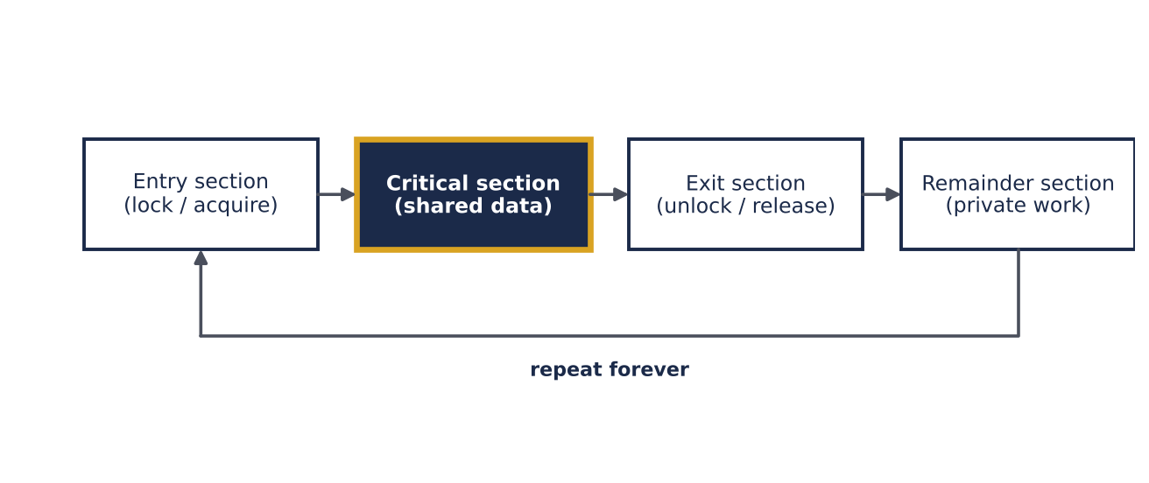
Figure 1 — General structure of a process in the critical-section problem

Race Conditions: Why Synchronization Is Needed
The simple statement counter++ is not one machine action. It consists of three steps: load the value, add one, and store the result. If two threads interleave these steps, one update is lost. Table 1 shows this for an initial value of counter = 5: after two increments the expected value is 7, but the result is 6.
Table 1 — An interleaving of two threads that loses an update (initial value 5)
Step | Thread 1 | Thread 2 | Memory | Registers
1 | R1 = counter | — | 5 | R1=5
2 | — | R2 = counter | 5 | R1=5, R2=5
3 | R1 = R1 + 1 | — | 5 | R1=6, R2=5
4 | — | R2 = R2 + 1 | 5 | R1=6, R2=6
5 | counter = R1 | — | 6 | —
6 | — | counter = R2 | 6 (expected 7) | —

The Three Requirements of a Correct Solution
Every solution must satisfy three classical requirements, which are the main yardsticks of the later comparison: mutual exclusion (no two processes inside their critical sections at the same time), progress (when the critical section is free, the choice of the next process cannot be postponed indefinitely and involves only processes that want to enter) and bounded waiting (there is a bound on how many times others may enter after a process has requested entry, i.e. no starvation).

Comparison Criteria
The algorithms are judged by: (1) mutual exclusion, (2) progress, (3) bounded waiting, (4) busy waiting and CPU use, (5) number of supported processes and scalability, (6) hardware/OS support needed, (7) deadlock and starvation, (8) code size and complexity, (9) ease of use and verification, and (10) practical use.
Table 2 — Overview of the five studied solutions
Solution | Level | Year / inventor | Nature | Core idea
Dekker | Software | 1965 · T. J. Dekker (published by Dijkstra) | Algorithm, 2 processes | flag + turn, back-off
Peterson | Software | 1981 · G. L. Peterson | Algorithm, 2 processes | flag + victim (turn)
Semaphore | OS primitive | 1965 · E. W. Dijkstra | Synchronization primitive | integer + P / V + queue
Monitor | Language construct | 1974 · C. A. R. Hoare | Abstract data type | mutex + condition variables
Readers–Writers | Problem / pattern | 1971 · Courtois, Heymans, Parnas | Synchronization problem | shared reads, exclusive writes

2. Dekker's Algorithm

History and Idea
Dekker's algorithm is the first correct software solution to the mutual-exclusion problem for two processes. It was devised by the Dutch mathematician T. J. Dekker around 1960 and published and generalised to N processes by E. W. Dijkstra in 1965. Its historical value is that it needs no special hardware instruction such as Test-and-Set — only reads and writes of shared variables.
The idea combines two mechanisms. First, each process raises a flag (wants[i]) to announce its interest. Second, the variable turn decides who has priority when both flags are up. The process without priority temporarily lowers its flag (back-off), waits until it is its turn and raises the flag again. This back-off separates the algorithm from naive flag-only solutions that deadlock.

Pseudocode
Pseudocode 1 — Dekker's algorithm for process i (j = 1 - i)
1 shared: boolean wants[2] = {false, false}
2 int turn = 0 // 0 or 1
3
4 process P(i): // j = 1 - i
5 loop forever
6 wants[i] <- true // announce interest
7 while wants[j] do
8 if turn != i then // the other has priority
9 wants[i] <- false // back off
10 wait until turn == i
11 wants[i] <- true
12 end while
13 ----- CRITICAL SECTION -----
14 turn <- j // give priority away
15 wants[i] <- false
16 ----- REMAINDER SECTION -----
17 end loop

C Implementation
The code uses standard C11 atomics. Using atomic_int (default seq_cst ordering) is essential: on modern processors, without memory barriers the CPU or compiler may reorder reads and writes and break the algorithm. The code was tested with two threads and a shared counter, which always ended with the correct value.
Listing 1 — Dekker lock (C11)
#include <stdatomic.h>

atomic_int wants[2]; /* wants[i] = 1 : process i wants to enter */
atomic_int turn = 0; /* who has priority when both want to enter */

void dekker_lock(int i) {
int j = 1 - i;
atomic_store(&wants[i], 1);
while (atomic_load(&wants[j])) { /* the other one wants too */
if (atomic_load(&turn) != i) { /* not my turn: back off */
atomic_store(&wants[i], 0);
while (atomic_load(&turn) != i) /* busy wait for my turn */
;
atomic_store(&wants[i], 1);
}
}
}

void dekker_unlock(int i) {
atomic_store(&turn, 1 - i); /* hand priority over */
atomic_store(&wants[i], 0);
}

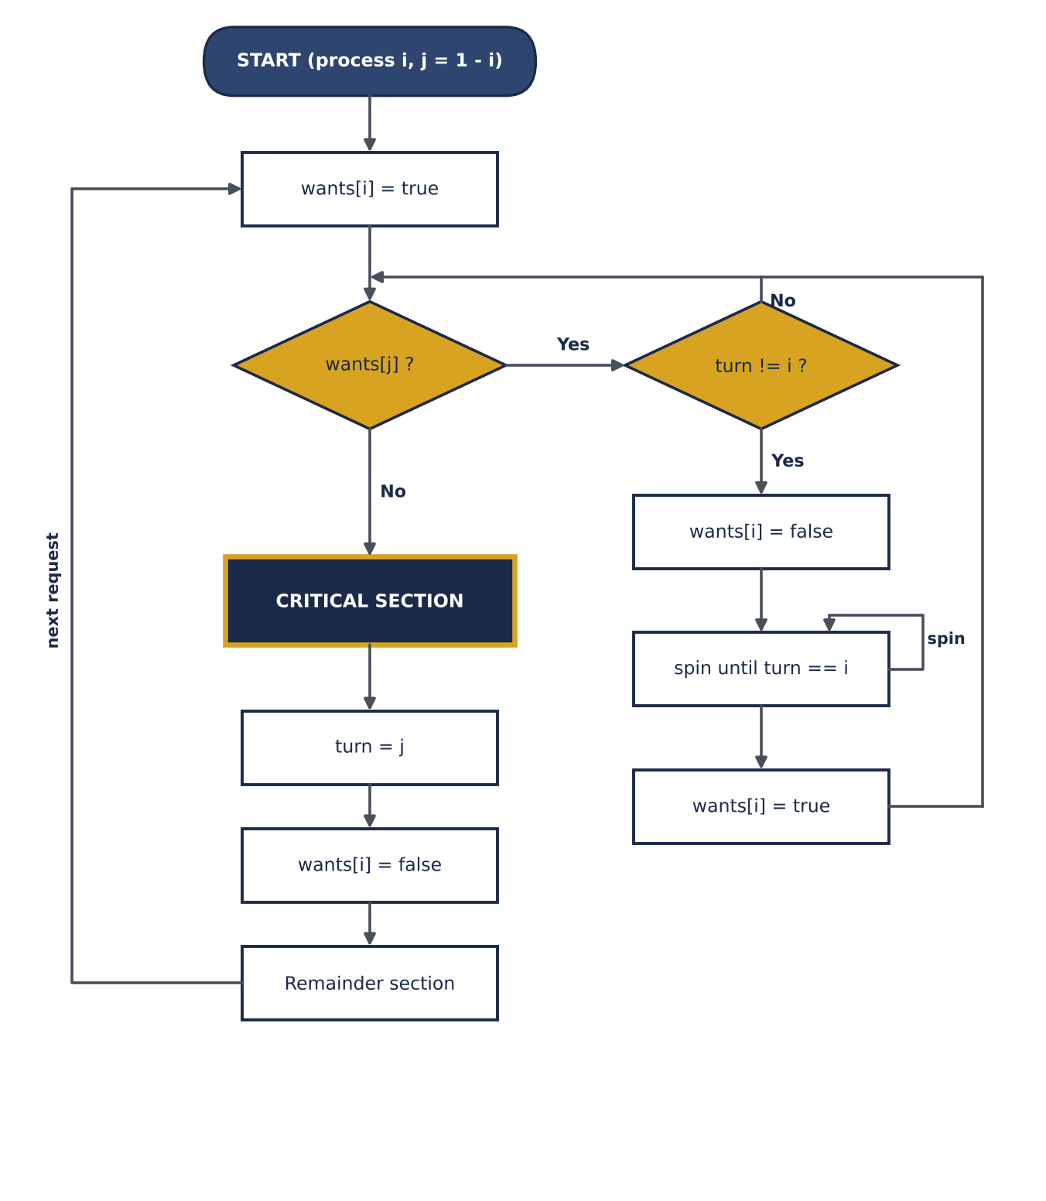
Figure 2 — Flowchart of Dekker's algorithm (process i)

Correctness Analysis
Mutual exclusion: to enter, process i must see wants[j] = false, but j raised its flag before checking wants[i], so at least one process sees the other's flag and both cannot enter. Progress: if both want to enter, turn picks a winner; the loser backs off, so there is no deadlock. Bounded waiting: a leaving process hands turn to its rival, so the rival waits at most one critical section.

Strengths and Weaknesses
Aspect | Strengths | Weaknesses
Hardware | No special instruction needed | Needs sequentially consistent memory (barriers)
CPU | Simple, tiny memory (3 variables) | Busy waiting wastes CPU cycles
Processes | Correct and starvation-free for 2 | Only 2 processes; N-process version is complex
Clarity | Historically important | Hard to understand and to prove; rarely used in practice

3. Peterson's Algorithm

History and Idea
In 1981 Gary L. Peterson published a short paper, "Myths about the Mutual Exclusion Problem", with an algorithm far simpler than Dekker's. It also needs only reads and writes of shared variables, but its logic is shorter and its correctness proof easier, which is why textbooks use it as the standard software algorithm.
Each process first announces interest (flag[i] = true) and then gives the turn to its rival (turn = j). It waits only while the rival is interested and the turn is the rival's. If both arrive simultaneously, the process that writes turn last has given the turn away and waits, so exactly one passes.

Pseudocode
Pseudocode 2 — Peterson's algorithm for process i (j = 1 - i)
1 shared: boolean flag[2] = {false, false}
2 int turn // the process that must wait
3
4 process P(i): // j = 1 - i
5 loop forever
6 flag[i] <- true // I am interested
7 turn <- j // let the other go first
8 while flag[j] and turn = j do
9 ; // busy wait
10 ----- CRITICAL SECTION -----
11 flag[i] <- false // I am done
12 ----- REMAINDER SECTION -----
13 end loop

C Implementation
Peterson's lock has only twelve effective lines of code. As with Dekker's algorithm, C11 atomics must be used. The order of the two writes in the entry section (flag[i] first, then turn) is crucial: swapping them breaks mutual exclusion.
Listing 2 — Peterson lock (C11)
#include <stdatomic.h>

atomic_int flag[2]; /* flag[i] = 1 : process i is interested */
atomic_int turn = 0; /* the process that must wait */

void peterson_lock(int i) {
int j = 1 - i;
atomic_store(&flag[i], 1); /* I am interested */
atomic_store(&turn, j); /* politely give the turn away */
while (atomic_load(&flag[j]) && atomic_load(&turn) == j)
; /* busy wait */
}

void peterson_unlock(int i) {
atomic_store(&flag[i], 0);
}

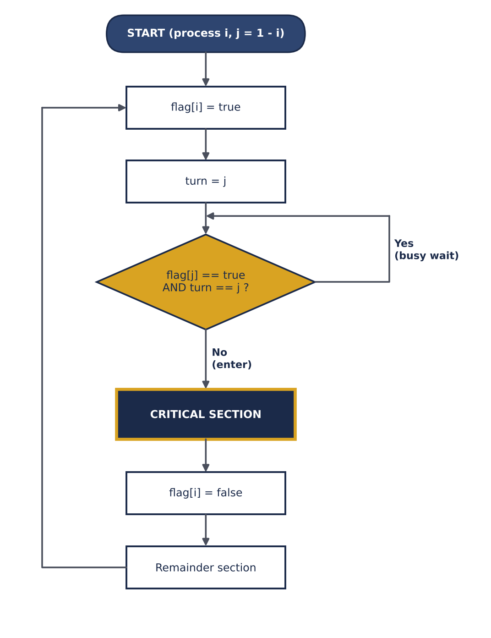
Figure 3 — Flowchart of Peterson's algorithm (process i)

Execution Timeline
Figure 4 shows a sample run. P0 requests entry at time 1 and P1 at 1.5. P0 arrives first and takes the critical section while P1 busy-waits until time 5. In the second round both arrive almost together; since P1 is the last writer of turn, it has given the turn to P0 and waits.
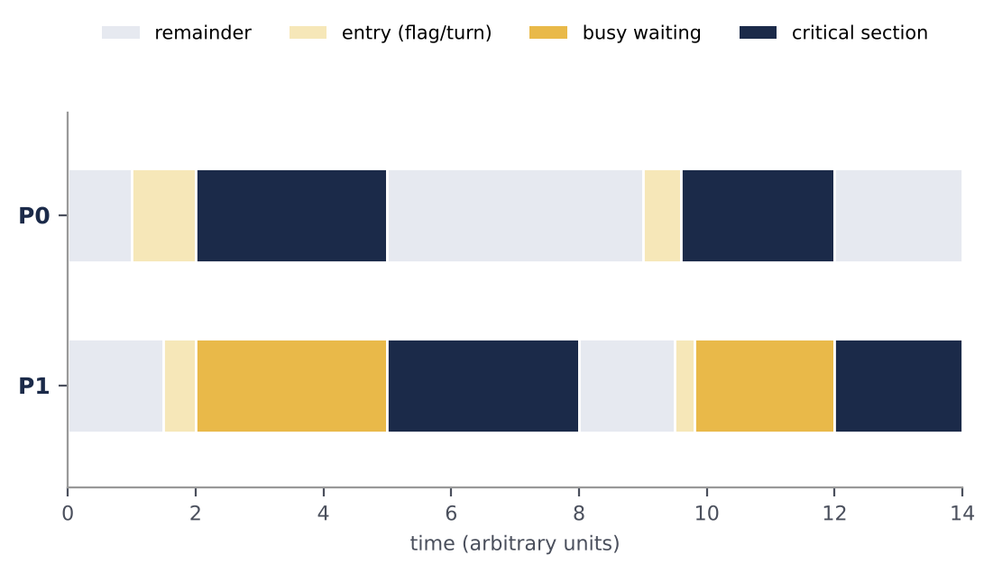
Figure 4 — Timeline of two processes under Peterson's algorithm

Correctness Analysis
Mutual exclusion: suppose both are inside. Each must have seen the loop condition false: P0 saw flag[1]=false or turn=0, and P1 saw flag[0]=false or turn=1. Both raised their flags before writing turn, so only turn being 0 and 1 at once remains, which is impossible. Progress: a process in its remainder section has a lowered flag and never blocks the other. Bounded waiting: if the rival re-requests immediately, it writes turn in favour of the waiting process, so the wait is at most one critical section.
Practical warning
On multicore CPUs without memory barriers (or with plain volatile variables) Peterson's algorithm can fail. Also, if the thread holding the critical section is preempted, its rival burns its whole time slice busy-waiting — we observed this in our own tests on a single CPU core.

Strengths and Weaknesses
Aspect | Strengths | Weaknesses
Simplicity | Very short, easy to prove correct | Limited to 2 processes
Fairness | Strict bounded waiting (at most 1 turn) | Busy waiting wastes CPU
Hardware | Only atomic loads and stores | Fails without memory barriers on modern CPUs
N processes | Filter lock generalisation exists | Filter lock needs N-1 levels and 2N-1 variables

4. Semaphores

Definition and Idea
Semaphores were introduced by Edsger W. Dijkstra in 1965. A semaphore is an integer variable modified only through two atomic operations: wait(S) (originally P, from Dutch *proberen*, "to test") and signal(S) (originally V, *verhogen*, "to increment"). wait decrements the value and blocks the process if no resource is left; signal increments it and wakes a waiting process if there is one. Unlike Dekker and Peterson, a waiting process releases the CPU and sleeps.

Types
Binary (mutex): value 0 or 1, used for mutual exclusion. Counting: any non-negative value, used to manage N instances of a resource (e.g. N free buffer slots). Strong vs weak: a strong semaphore has a FIFO wait queue and guarantees bounded waiting; a weak one wakes processes in unspecified order, so starvation is possible.

Pseudocode
Pseudocode 3 — Blocking semaphore implementation
1 type semaphore = record
2 int value
3 list queue // processes blocked on this semaphore
4 end record
5
6 wait(S): // executed atomically
7 S.value <- S.value - 1
8 if S.value < 0 then
9 append this process to S.queue
10 block() // sleep, CPU is released
11
12 signal(S): // executed atomically
13 S.value <- S.value + 1
14 if S.value <= 0 then
15 remove a process Q from S.queue
16 wakeup(Q)

Pseudocode 4 — Mutual exclusion and producer–consumer
1 // (a) mutual exclusion with a binary semaphore
2 semaphore mutex = 1
3 process P(i):
4 loop forever
5 wait(mutex)
6 ----- CRITICAL SECTION -----
7 signal(mutex)
8 ----- REMAINDER SECTION -----
9
10 // (b) bounded buffer with capacity N
11 semaphore empty = N, full = 0, mutex = 1
12
13 producer: consumer:
14 loop forever loop forever
15 item <- produce() wait(full)
16 wait(empty) wait(mutex)
17 wait(mutex) item <- buffer.remove()
18 buffer.insert(item) signal(mutex)
19 signal(mutex) signal(empty)
20 signal(full) consume(item)

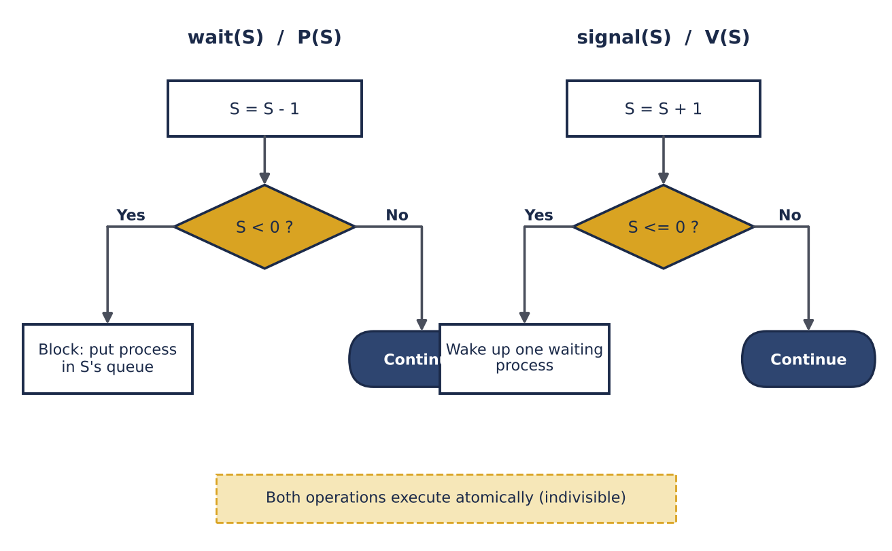
Figure 5 — wait and signal operations of a blocking semaphore

C Implementation
The code solves the bounded-buffer problem with POSIX semaphores. empty counts free slots (the producer waits on it), full counts filled slots (the consumer waits on it) and mutex protects the buffer indices. In our test one producer generated 100,000 numbers, one consumer consumed them all, and the sum came out exactly right.
Listing 3 — Bounded buffer with POSIX semaphores
#include <semaphore.h>

#define N 8 /* buffer capacity */
int buf[N], in = 0, out = 0;

sem_t empty_slots; /* init: N (free slots) */
sem_t full_slots; /* init: 0 (filled slots) */
sem_t mutex; /* init: 1 (binary semaphore) */

void init(void) {
sem_init(&empty_slots, 0, N);
sem_init(&full_slots, 0, 0);
sem_init(&mutex, 0, 1);
}

void produce(int item) {
sem_wait(&empty_slots); /* P(empty) */
sem_wait(&mutex); /* P(mutex) */
buf[in] = item; in = (in + 1) % N;
sem_post(&mutex); /* V(mutex) */
sem_post(&full_slots); /* V(full) */
}

int consume(void) {
int item;
sem_wait(&full_slots); /* P(full) */
sem_wait(&mutex); /* P(mutex) */
item = buf[out]; out = (out + 1) % N;
sem_post(&mutex); /* V(mutex) */
sem_post(&empty_slots); /* V(empty) */
return item;
}

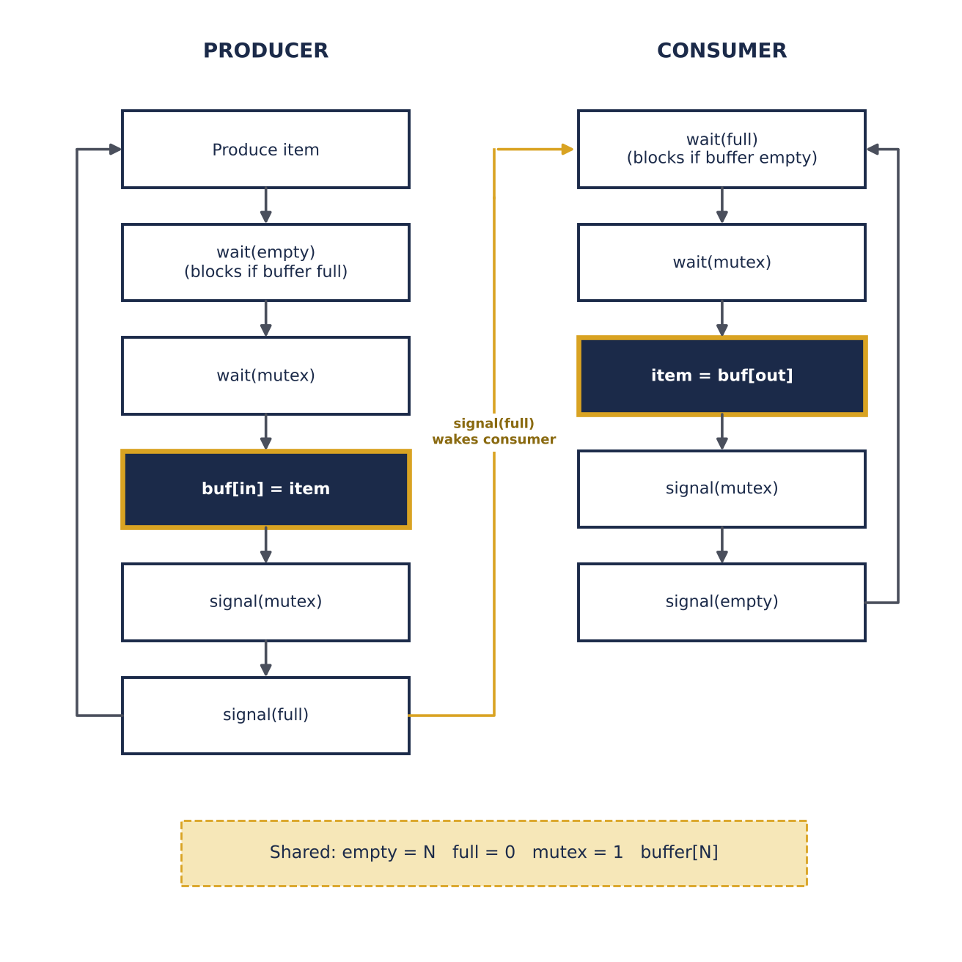
Figure 6 — Producer–consumer flowchart with semaphores
Figure 7 shows the semaphore values for a buffer of capacity 3 and ten consecutive operations. empty + full always equals 3. After step 3 the buffer is full (empty = 0); a fourth production at that moment would block on wait(empty) until the consumer frees a slot in step 4.
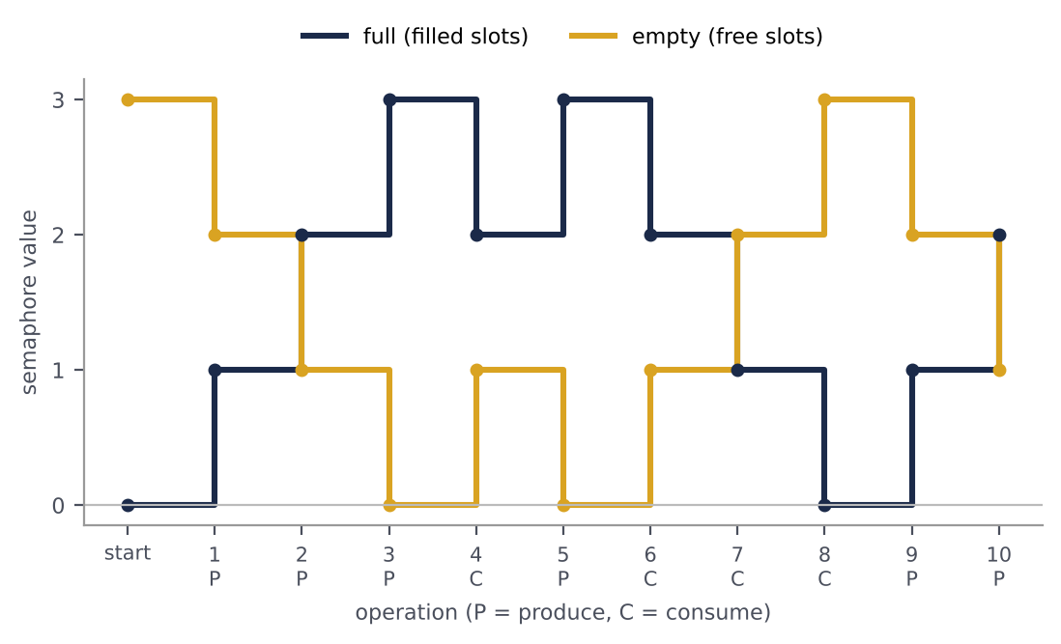
Figure 7 — Values of the empty and full semaphores (buffer capacity 3)

Analysis and Pitfalls
Mutual exclusion: with initial value 1 and matched wait/signal pairs at most one process passes. Deadlock: if the producer swaps wait(mutex) and wait(empty), it may sleep on empty while holding mutex, and the consumer can never obtain mutex. Programmer error: a forgotten signal or an extra wait leads to deadlock or broken exclusion, and the compiler cannot help because the calls are scattered. Priority inversion: a low-priority process holding a semaphore can stall a high-priority one (as in the 1997 Mars Pathfinder case).
Aspect | Strengths | Weaknesses
CPU | Blocking: waiting process sleeps, no CPU waste | Context-switch cost for very short critical sections
Generality | Mutual exclusion and signalling; N processes | Low-level; easy to misuse (order, forgotten signal)
Fairness | Strong semaphores give bounded waiting | Weak semaphores may starve
Support | Provided by all major OSs (POSIX, Windows) | Needs OS and atomic hardware support

5. Monitors

Definition and Idea
Despite their power, semaphores are error-prone. In 1974 C. A. R. Hoare, building on Brinch Hansen's work, introduced the monitor as a high-level construct. A monitor is an abstract data type that bundles shared data, the procedures operating on it and the synchronization lock. The main rule: at most one thread is active inside the monitor at any time. The lock is acquired automatically on entering a procedure and released on leaving, so the programmer cannot forget it.
For conditional synchronization (e.g. "wait until the buffer is not full") monitors use condition variables. wait(c) puts the thread to sleep in the condition queue and releases the monitor lock at the same time; signal(c) wakes one waiting thread. Unlike a semaphore, a condition variable has no memory: a signal with no waiter is lost.

Two Signalling Styles: Hoare and Mesa
Feature | Hoare style | Mesa style
signal | Signaller yields the monitor to the woken thread at once | Signaller continues; woken thread only becomes ready
Condition test | if is sufficient (condition still true) | Must use while (condition may have changed)
Cost | More context switches | Cheaper; used in practice
Implementations | Textbooks, theory | Java, C#, POSIX threads, Python

Pseudocode
Pseudocode 5 — Bounded-buffer monitor
1 monitor BoundedBuffer
2 var buf[N], in = 0, out = 0, count = 0
3 condition notFull, notEmpty
4
5 procedure put(item)
6 while count = N do wait(notFull) // Mesa style: re-test
7 buf[in] <- item; in <- (in + 1) mod N; count <- count + 1
8 signal(notEmpty)
9
10 procedure get() returns item
11 while count = 0 do wait(notEmpty)
12 item <- buf[out]; out <- (out + 1) mod N; count <- count - 1
13 signal(notFull)
14 return item
15 end monitor
16 // the monitor lock is acquired on entry and released on exit
17 // of every procedure (and while waiting) automatically

C and Java Implementations
C has no monitors, but one can be built from a pthread_mutex_t and some pthread_cond_t variables. In Java every object is intrinsically a monitor: synchronized acquires the lock, and wait() / notifyAll() act as the condition variable. The C version was tested with one producer, one consumer and 100,000 items; the Java version follows the standard idiom.
Listing 4 — Bounded-buffer monitor with pthreads (C)
#include <pthread.h>

#define N 8
/* ---- monitor "BoundedBuffer" : all data + lock + conditions ---- */
typedef struct {
int buf[N];
int in, out, count;
pthread_mutex_t lock; /* the monitor's implicit mutex */
pthread_cond_t not_full; /* condition variable */
pthread_cond_t not_empty; /* condition variable */
} Monitor;

Monitor m = { .lock = PTHREAD_MUTEX_INITIALIZER,
.not_full = PTHREAD_COND_INITIALIZER,
.not_empty = PTHREAD_COND_INITIALIZER };

void mon_put(int item) { /* monitor procedure */
pthread_mutex_lock(&m.lock); /* enter monitor */
while (m.count == N) /* Mesa style: while */
pthread_cond_wait(&m.not_full, &m.lock);
m.buf[m.in] = item; m.in = (m.in + 1) % N; m.count++;
pthread_cond_signal(&m.not_empty);
pthread_mutex_unlock(&m.lock); /* leave monitor */
}

int mon_get(void) { /* monitor procedure */
pthread_mutex_lock(&m.lock);
while (m.count == 0)
pthread_cond_wait(&m.not_empty, &m.lock);
int item = m.buf[m.out]; m.out = (m.out + 1) % N; m.count--;
pthread_cond_signal(&m.not_full);
pthread_mutex_unlock(&m.lock);
return item;
}

Listing 5 — Bounded-buffer monitor in Java
public class BoundedBuffer {
private final int[] buf;
private int in = 0, out = 0, count = 0;

public BoundedBuffer(int capacity) { buf = new int[capacity]; }

public synchronized void put(int item) throws InterruptedException {
while (count == buf.length) // Mesa semantics: always re-test
wait();
buf[in] = item; in = (in + 1) % buf.length; count++;
notifyAll(); // wake up waiting threads
}

public synchronized int get() throws InterruptedException {
while (count == 0)
wait();
int item = buf[out]; out = (out + 1) % buf.length; count--;
notifyAll();
return item;
}
}

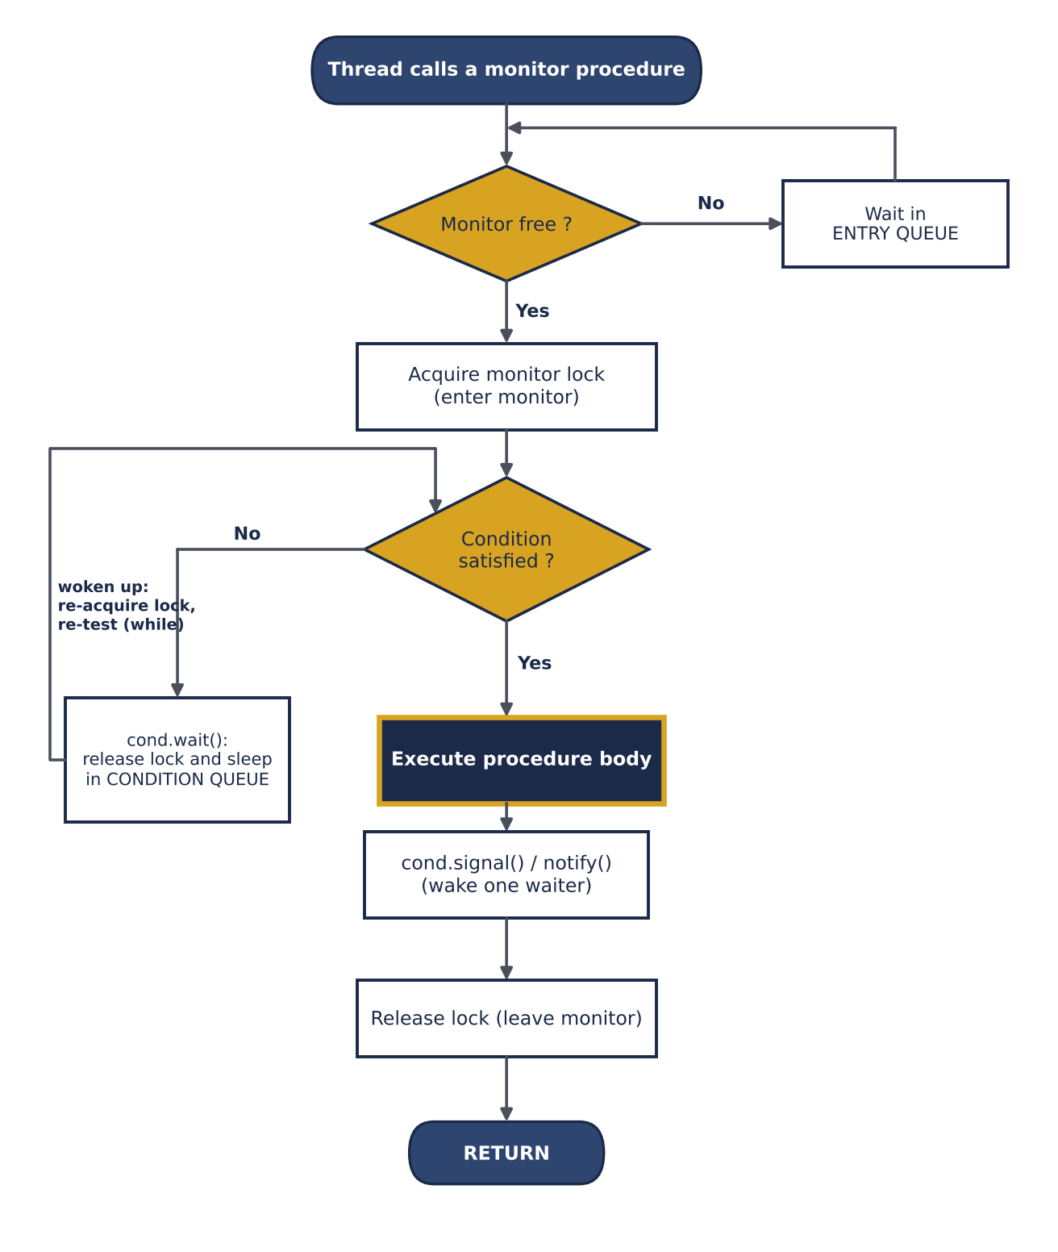
Figure 8 — Flowchart of executing a monitor procedure

Analysis
Mutual exclusion is guaranteed structurally; no user code is needed to lock. Queues: threads have an entry queue and one queue per condition variable; bounded waiting depends on the scheduling policy (FIFO queues). Deadlock: nested monitor calls or a wait without a matching signal can deadlock. Pitfall: in Mesa style the while loop is mandatory — using if causes errors through spurious wakeups.
Aspect | Strengths | Weaknesses
Safety | Lock handled by the language; hard to misuse | Requires language/runtime support (not in plain C)
Modularity | Data + synchronization encapsulated in one unit | Nested calls can deadlock
Conditions | Condition variables express complex waits clearly | Signal semantics (Hoare vs Mesa) confuse beginners
Performance | Blocking, no busy waiting | Coarse lock: one thread at a time inside the whole monitor

6. Readers–Writers

Problem Statement
The Readers–Writers problem was posed by Courtois, Heymans and Parnas in 1971. Several "reader" processes only read shared data and several "writer" processes modify it. Rules: (1) many readers may read simultaneously; (2) a writer needs exclusive access — no readers and no other writer. It models databases, caches and file systems, where reads vastly outnumber writes and full exclusion (like a plain mutex) wastes performance.
Note
Readers–Writers is a synchronization *problem*, not a primitive like the semaphore. Because its standard solutions are textbook algorithms and appear in libraries as read/write locks (RW-locks), it is compared here alongside the other algorithms.

The Three Variants
Variant | Rule | Consequence
First (readers preference) | No reader waits unless a writer already holds the data | Writers may starve
Second (writers preference) | Once a writer waits, no new reader may start | Readers may starve
Third (fair) | Requests served in arrival order (turnstile / queue) | No starvation, slightly lower read concurrency

Pseudocode
Pseudocode 6 — First readers–writers problem (readers preference)
1 shared: semaphore mutex = 1, rw_mutex = 1
2 int read_count = 0
3
4 writer: reader:
5 wait(rw_mutex) wait(mutex)
6 ----- WRITE ----- read_count <- read_count + 1
7 signal(rw_mutex) if read_count = 1 then wait(rw_mutex)
8 signal(mutex)
9 ----- READ -----
10 wait(mutex)
11 read_count <- read_count - 1
12 if read_count = 0 then signal(rw_mutex)
13 signal(mutex)

Pseudocode 7 — Fair version with a turnstile
1 shared: semaphore mutex = 1, rw_mutex = 1, turnstile = 1
2 int read_count = 0
3
4 writer: reader:
5 wait(turnstile) wait(turnstile) // pass the gate
6 wait(rw_mutex) signal(turnstile)
7 ----- WRITE ----- (same entry code as before)
8 signal(turnstile) ----- READ -----
9 signal(rw_mutex) (same exit code as before)
10 // a waiting writer holds the turnstile, so no new reader can pass it

In the first version the "first reader" locks the writers out and the "last reader" lets them in; the counter read_count is protected by mutex. In the fair version a waiting writer closes the turnstile and new readers queue behind it, so the writer is served as soon as the current readers leave.

C Implementation
The code below provides both versions using POSIX semaphores. In the test, three readers and two writers ran concurrently; writers incremented two array elements with a pause in between, and readers checked that the two were always equal. No violation was seen in either version.
Listing 6 — Readers–Writers (basic and fair)
#include <semaphore.h>

/* ---------- Readers-Writers, first problem (readers preference) ---------- */
sem_t rw_mutex; /* init 1 : exclusive access to the data */
sem_t mutex; /* init 1 : protects read_count */
int read_count = 0;

void writer_enter(void) { sem_wait(&rw_mutex); }
void writer_exit (void) { sem_post(&rw_mutex); }

void reader_enter(void) {
sem_wait(&mutex);
if (++read_count == 1) /* first reader locks out the writers */
sem_wait(&rw_mutex);
sem_post(&mutex);
}
void reader_exit(void) {
sem_wait(&mutex);
if (--read_count == 0) /* last reader lets the writers in */
sem_post(&rw_mutex);
sem_post(&mutex);
}

/* ---------- Fair version: a turnstile stops new readers once a writer waits ---------- */
sem_t turnstile; /* init 1 */

void fair_writer_enter(void) { sem_wait(&turnstile); sem_wait(&rw_mutex); }
void fair_writer_exit (void) { sem_post(&turnstile); sem_post(&rw_mutex); }

void fair_reader_enter(void) {
sem_wait(&turnstile); sem_post(&turnstile); /* pass through the gate */
reader_enter();
}
void fair_reader_exit(void) { reader_exit(); }

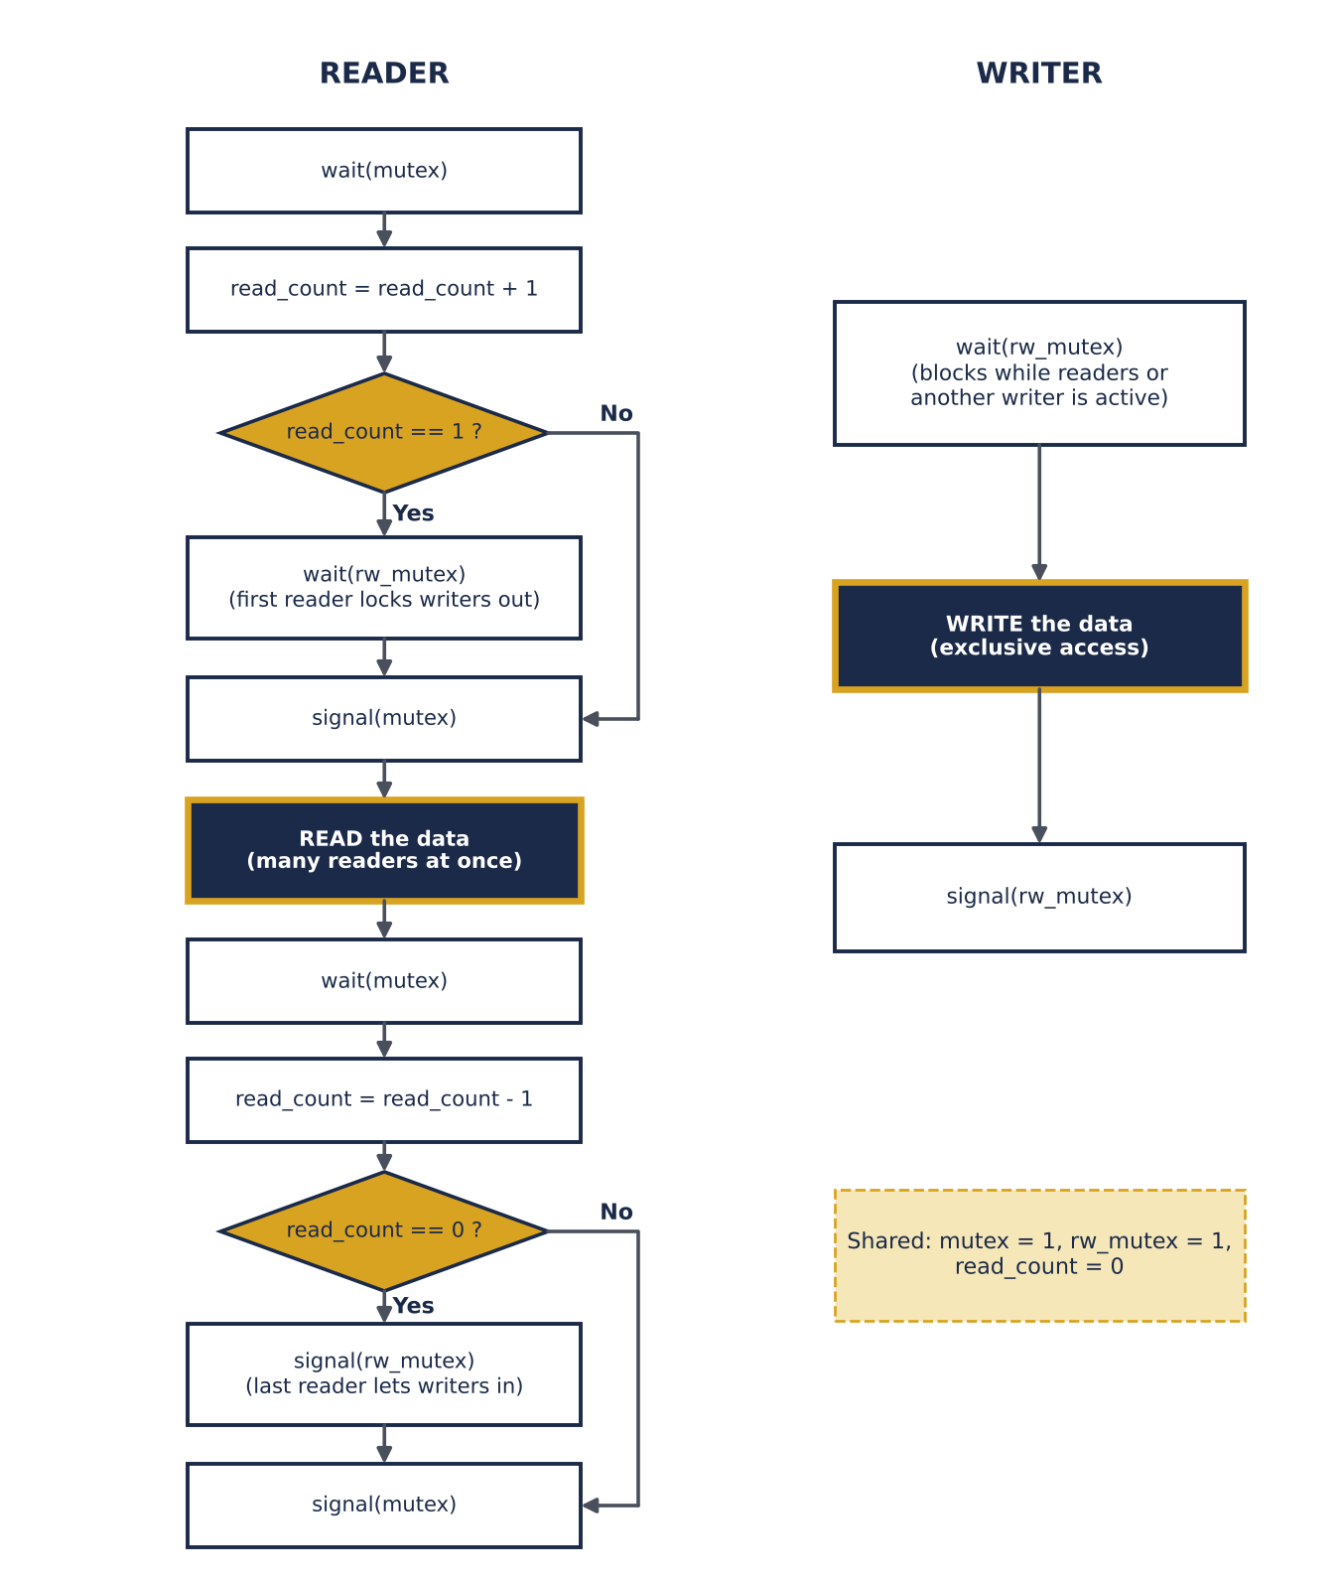
Figure 9 — Flowchart of reader and writer (first variant)

Timeline and Starvation
Figure 10 shows a run of the first variant. Writer W1 requests at time 2, but since reader R3 can still join the active readers at time 4, W1 waits until time 7. If new readers keep arriving, W1 never gets its turn — this is writer starvation in the first variant.
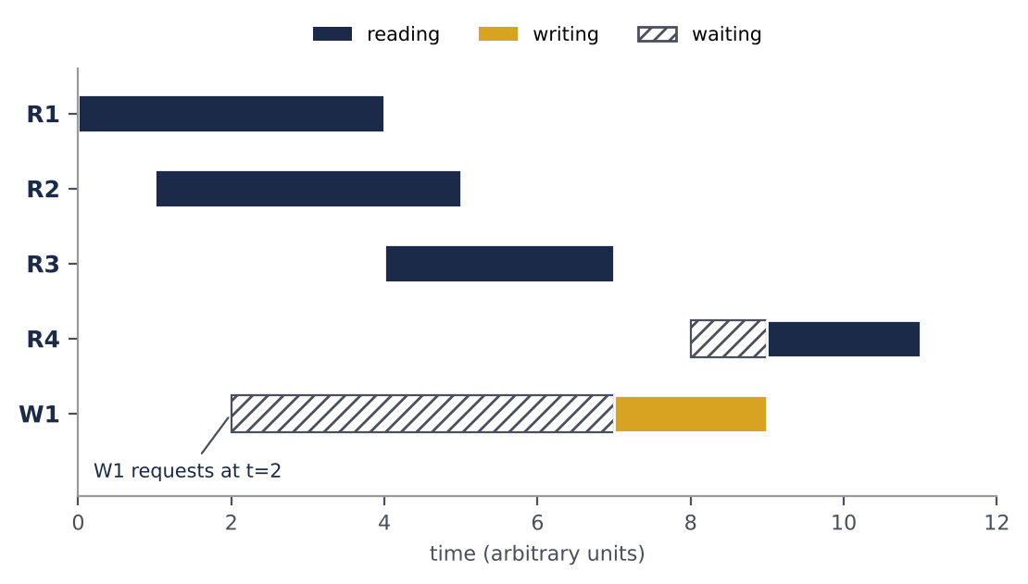
Figure 10 — Gantt chart: writer starvation in the first variant

Analysis
Mutual exclusion: a writer excludes everybody via rw_mutex; readers share access with each other but not with writers. Concurrency: up to N readers read simultaneously — a property none of the other four algorithms offers. Starvation: variant 1 starves writers, variant 2 starves readers, variant 3 starves neither. Use: pthread_rwlock_t in POSIX and ReentrantReadWriteLock in Java provide this pattern ready-made.
Aspect | Strengths | Weaknesses
Throughput | Parallel reads: high throughput for read-heavy loads | If writes are frequent, a plain mutex is simpler and as fast
Fairness | Fair variant avoids starvation | Basic variants starve writers or readers
Complexity | Built from 2-3 semaphores and a counter | More states and subtle ordering than a simple lock

7. Comprehensive Comparison
This chapter compares the five solutions from two points of view: correctness and behaviour (Table 3) and engineering and efficiency (Table 4). A qualitative scoring follows in Table 5, together with comparison charts. Quantitative values such as lines of code come from the tested listings of this article.

Correctness and Behaviour
Table 3 — Correctness and behaviour properties (mutual exclusion, progress, bounded waiting, …)
Parameter | Dekker | Peterson | Semaphore | Monitor | Readers–Writers
Mutual exclusion | Yes | Yes | Yes | Yes (structural) | Writers exclusive, readers shared
Progress | Yes | Yes | Yes | Yes | Yes
Bounded waiting | Yes (≤ 1 turn) | Yes (≤ 1 turn) | Only strong (FIFO) semaphores | Depends on queue policy | Variants 1/2 no, fair variant yes
Starvation | No | No | Possible (weak semaphore) | Possible (Mesa barging) | Possible (writer or reader)
Deadlock | No | No | Possible (wrong wait order) | Possible (nested monitors) | Not by itself; possible with other locks
Busy waiting | Yes | Yes | No (blocking) | No | No
Processes | 2 | 2 | N | N | N readers + M writers
Concurrency inside CS | No | No | Counting: up to k threads | No (one thread) | Yes: parallel readers
Conditional signalling | No | No | Yes (wait / signal) | Yes (condition variables) | Via semaphores / monitors
Priority inversion | Possible while spinning | Possible while spinning | Possible | Possible | Possible

Engineering and Efficiency
Table 4 — Engineering parameters: hardware, CPU, scalability, complexity and use
Parameter | Dekker | Peterson | Semaphore | Monitor | Readers–Writers
Level | Software algorithm | Software algorithm | OS primitive | Language construct | Synchronization pattern
Support needed | Atomic load/store + barriers | Atomic load/store + barriers | OS scheduler + atomic ops | Language or mutex/cond library | Semaphores / monitor / RW-lock
CPU while waiting | High (spins) | High (spins) | Low (sleeps) | Low (sleeps) | Low (sleeps)
Scalability | Poor (2N+1 vars) | Poor (filter: 2N−1) | Good (1 var) | Good | Good (3 vars)
Lines of code (our listings) | 18 | 12 | 26 | 28 (C) | 25
Sync variables (2 procs) | 3 | 3 | 3 | 3 (lock + 2 conditions) | 3
Ease of verification | Hard | Medium (short proof) | Medium (error-prone) | Easy (structured) | Medium
Multicore reliability | Needs fences | Needs fences | Reliable | Reliable | Reliable
Modern use | Teaching, theory | Teaching, model checking | Kernels, POSIX, Windows | Java, C#, Python | Databases, caches, file systems

Qualitative Scoring
Table 5 gives each criterion a score from 1 (poor) to 5 (excellent). The scores are the author's qualitative judgement based on the previous tables, not measurements. A higher "independence from OS and hardware" means less support is needed. All criteria have equal weight; the average is in the last row.
Table 5 — Qualitative scores of the solutions (1–5)
Parameter | Dekker | Peterson | Semaphore | Monitor | Readers–Writers
Mutual-exclusion safety | 5 | 5 | 5 | 5 | 5
Fairness / bounded waiting | 4 | 5 | 4 | 4 | 2
CPU efficiency | 1 | 1 | 4 | 4 | 4
Scalability | 1 | 1 | 5 | 5 | 4
Ease of programming | 1 | 2 | 3 | 5 | 3
Independence from OS / HW | 4 | 4 | 2 | 1 | 2
Average | 2.67 | 3.00 | 3.83 | 4.00 | 3.33

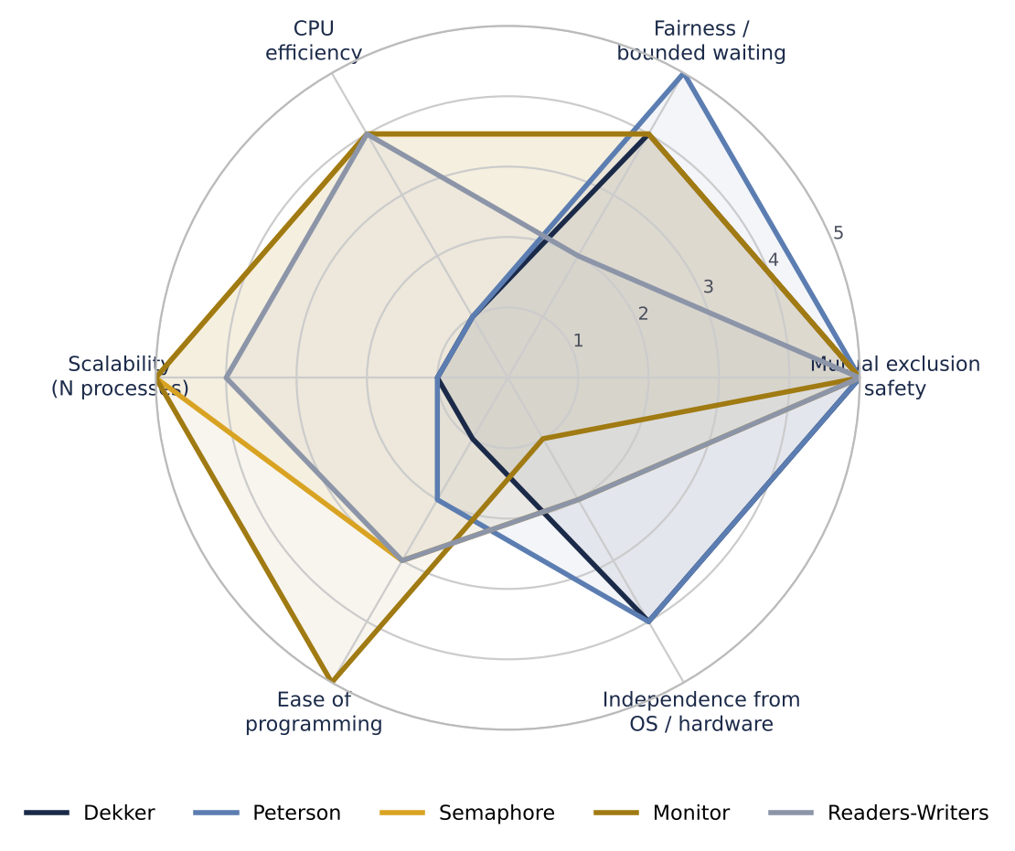
Figure 11 — Radar chart comparing the six criteria
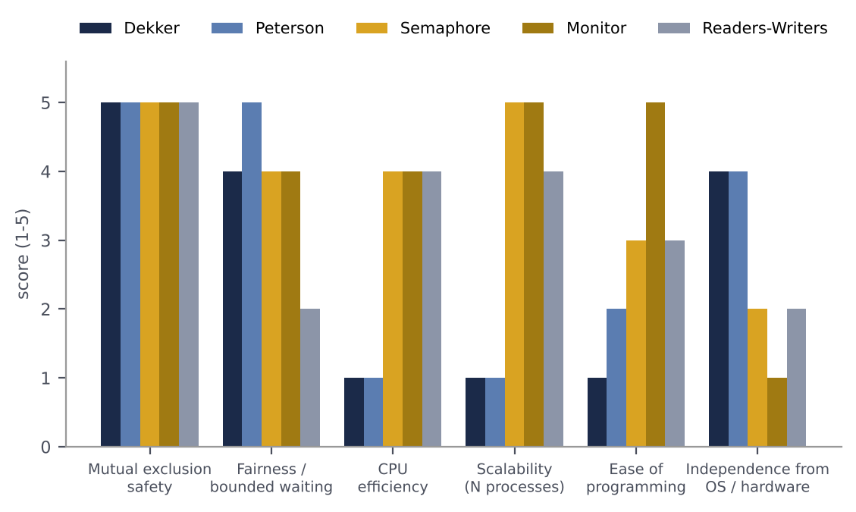
Figure 12 — Grouped bar chart of the score per criterion
The radar chart shows that Dekker and Peterson are strong only in safety and independence from the OS, while semaphores and monitors win in efficiency and scalability. Monitors are the easiest to program but depend on language support. The basic Readers–Writers solution is weaker in fairness but provides parallel reads.
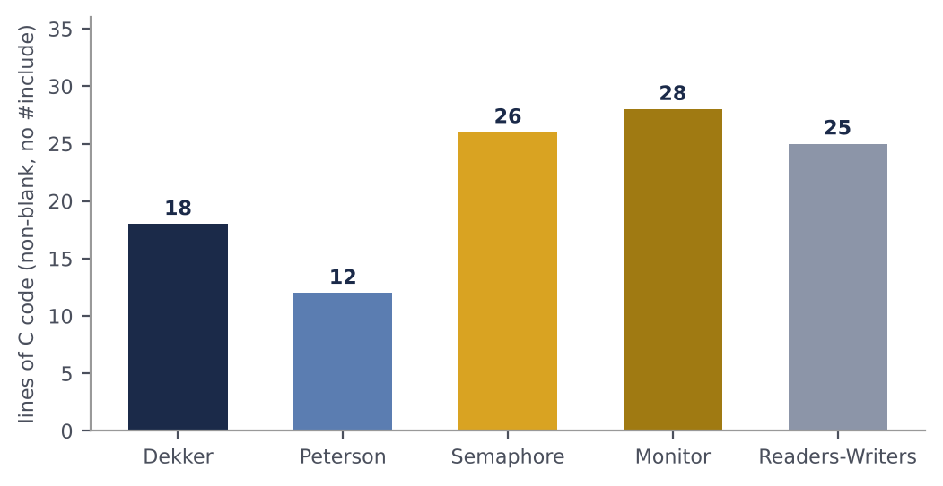
Figure 13 — Implementation size (effective C lines)
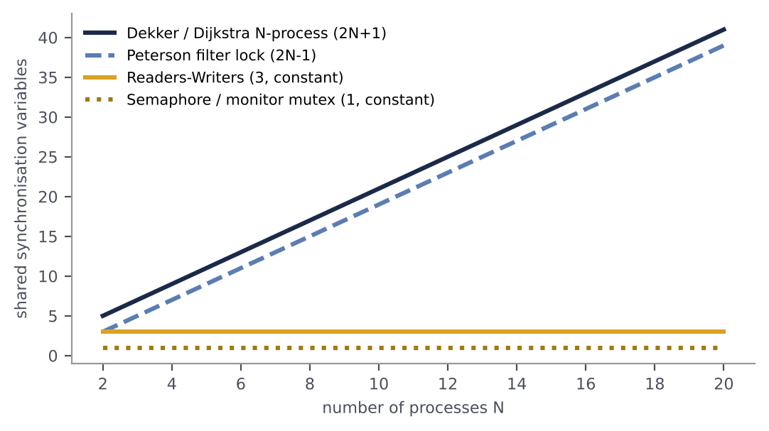
Figure 14 — Shared synchronization variables versus number of processes
Figure 14 shows scalability. Generalising software algorithms to N processes needs a linear number of variables (about 2N) and every entry must read all of them, whereas semaphores and monitors use a constant number of variables for any number of processes and put threads to sleep instead of spinning.

8. Worked Examples and Sample Questions
For each of the five algorithms we give one worked example (a step-by-step trace) and three sample questions (two multiple-choice and one descriptive) with answers. In all traces the scheduler is assumed to execute one statement of one process at a time.

Dekker

Example 1: simultaneous arrival
Initial state: wants = [F, F], turn = 0. Both processes request entry at the same time. Determine which one enters.
Step | Process | Action | wants[0], wants[1] | turn
1 | P0 | wants[0] = true | T, F | 0
2 | P1 | wants[1] = true | T, T | 0
3 | P0 | sees wants[1]=T; turn = 0 = i, so no back-off; keeps looping | T, T | 0
4 | P1 | sees wants[0]=T; turn ≠ 1 → back off: wants[1] = false; spins | T, F | 0
5 | P0 | sees wants[1]=F → leaves loop → enters CS | T, F | 0
6 | P0 | exit: turn = 1; wants[0] = false | F, F | 1
7 | P1 | turn = 1 → wants[1] = true; wants[0]=F → enters CS | F, T | 1

Result: P0 enters first because turn = 0 gives it priority; P1 backs off and enters right after P0 leaves. Mutual exclusion and bounded waiting hold.

Question 1. What is the purpose of the back-off (wants[i] = false) in Dekker's algorithm?
(a) faster execution (b) avoid deadlock when both flags are up and the turn is the rival's (c) free memory (d) switch the turn
Answer: (b). The process without priority lowers its flag so that its rival can pass.
Question 2. For how many processes does the original Dekker algorithm work?
(a) 1 (b) 2 (c) N (d) unlimited
Answer: (b). Dijkstra presented the N-process version separately.
Question 3. If turn = j is removed from the exit section, which requirement is violated? Explain.
Answer: Bounded waiting. If turn stays 0 forever, P1 must back off in every conflict while P0, requesting repeatedly, can always win, so P1 starves. Mutual exclusion still holds.

Peterson

Example 2: trace and statement order
Initial state: flag = [F, F]. P0 and P1 interleave. In each loop condition j is the rival.
Step | Process | Action | flag[0], flag[1] | turn
1 | P0 | flag[0] = true | T, F | ?
2 | P1 | flag[1] = true | T, T | ?
3 | P1 | turn = 0 (gives the turn to P0) | T, T | 0
4 | P0 | turn = 1 (gives the turn to P1) | T, T | 1
5 | P0 | flag[1] ∧ turn = 1 → TRUE → P0 waits | T, T | 1
6 | P1 | flag[0] ∧ turn = 0 → FALSE → P1 enters CS | T, T | 1
7 | P1 | exit: flag[1] = false | T, F | 1
8 | P0 | flag[1] = F → condition FALSE → P0 enters CS | T, F | 1

Result: the last process to write turn (P0) waits and the other (P1) enters.

Question 4. In Peterson's algorithm, if two processes arrive simultaneously, which one waits?
(a) the first to raise its flag (b) the last to write turn (c) the lower-numbered process (d) both
Answer: (b).
Question 5. Which is Peterson's waiting condition?
(a) flag[j] || turn == j (b) flag[j] && turn == j (c) !flag[j] && turn == i (d) flag[i] && turn == i
Answer: (b): a process waits only if the rival is interested and the turn is the rival's.
Question 6. Swap the two entry statements (turn = j first, then flag[i] = true). Show that mutual exclusion is violated.
Answer: Trace: P0: turn = 1; P1: turn = 0; P1: flag[1] = true, and since flag[0] = false P1 enters the CS; then P0: flag[0] = true, and since turn = 0 the test turn == 1 is false so P0 enters too. Both are inside the CS.

Semaphore

Example 3: bounded buffer of capacity 2
Initial values: empty = 2, full = 0. In the blocking implementation a semaphore can become negative (its absolute value is the number of waiting processes).
Step | Action | empty | full | Note
1 | Producer: wait(empty) … signal(full) (item A) | 1 | 1 | A stored
2 | Producer: item B | 0 | 2 | buffer full
3 | Producer: wait(empty) for item C | −1 | 2 | producer BLOCKS (queue: Prod)
4 | Consumer: wait(full) … removes A | −1 | 1 | one slot freed
5 | Consumer: signal(empty) | 0 | 1 | value ≤ 0 → wakes producer
6 | Producer resumes, stores C, signal(full) | 0 | 2 | buffer full again

Result: empty + full always equals the capacity (2), except while a process is blocked. The producer sleeps in step 3 without wasting CPU and is woken in step 5.

Question 7. What is the initial value of the mutex semaphore used for mutual exclusion?
(a) 0 (b) 1 (c) N (d) 2
Answer: (b); the value 1 means the critical section is free, and only one process passes wait.
Question 8. In the blocking implementation, what does a semaphore value of −3 mean?
(a) three free resources (b) three processes blocked in the queue (c) an error (d) three extra signals
Answer: (b).
Question 9. Why does swapping wait(mutex) and wait(empty) in the producer create a deadlock?
Answer: If the buffer is full, the producer takes mutex and then sleeps on wait(empty) while still holding mutex. The consumer needs wait(mutex) to free a slot and can never get it, so both wait forever.

Monitor

Example 4: why while? (Mesa style)
The buffer is empty. Consider consumers C1 and C2 and a producer P:
Step | Event | State
1 | C1 calls get(): count = 0 → wait(notEmpty); releases the lock | C1 sleeps in the notEmpty queue
2 | P calls put(10): count = 1; signal(notEmpty) | C1 becomes READY but P still holds the lock
3 | P leaves the monitor | lock is free
4 | C2 calls get() and acquires the lock first: takes the item, count = 0 | buffer empty again
5 | C1 re-acquires the lock and re-tests: count = 0 → TRUE | with while: C1 waits again (correct); with if: C1 would read an empty buffer (BUG)

Result: in Mesa style, being woken up does not guarantee that the condition still holds; therefore the condition must be re-tested in a while loop.

Question 10. Why is while used instead of if in a Mesa-style monitor?
(a) speed (b) the condition may change between the signal and resumption (c) compiler requirement (d) avoid stack overflow
Answer: (b).
Question 11. What is the difference between a semaphore signal and a condition-variable signal when nobody is waiting?
(a) none (b) the semaphore increments and remembers; the condition variable loses the signal (c) both raise errors (d) the semaphore loses it
Answer: (b).
Question 12. In this article's Java code, why is notifyAll() used instead of notify()?
Answer: Producers and consumers sleep on one shared wait set. notify() may wake the wrong kind (e.g. a producer while the buffer is still full); that thread sleeps again and the wake-up never reaches the real consumer, causing deadlock. notifyAll() wakes everyone and each thread re-tests its own condition.

Readers–Writers

Example 5: tracing the first variant
Events: R1 arrives at time 0, R2 at 1, writer W1 at 2, R3 at 3; R1 leaves at 4, R2 at 5 and R3 at 6.
Time | Event | read_count | rw_mutex | Note
0 | R1 enters: first reader → wait(rw_mutex) | 1 | 0 (taken) | R1 reads
1 | R2 enters | 2 | 0 | R1 and R2 read together
2 | W1: wait(rw_mutex) | 2 | 0 | W1 BLOCKS
3 | R3 enters (readers preference) | 3 | 0 | joins the readers
4 | R1 leaves | 2 | 0 | —
5 | R2 leaves | 1 | 0 | —
6 | R3 leaves: last reader → signal(rw_mutex) | 0 | 1 → W1 | W1 wakes and writes

Result: R3 overtook the waiting writer W1; with more arriving readers W1 would starve. In the fair version R3 would have waited at the turnstile.

Question 13. In the first Readers–Writers variant, which group may starve?
(a) readers (b) writers (c) neither (d) both
Answer: (b).
Question 14. What does the first reader do in the first variant?
(a) runs signal(mutex) (b) locks writers out with wait(rw_mutex) (c) waits for the writer (d) resets read_count
Answer: (b).
Question 15. How does the turnstile remove writer starvation?
Answer: The writer takes turnstile before rw_mutex and holds it until the write ends. A new reader must pass the turnstile and is held behind the writer, so only the current readers finish and the writer enters right after them.

9. Conclusion and Selection Guide
The study shows that none of the five solutions wins on every criterion. Dekker and Peterson prove that mutual exclusion is possible with plain reads and writes, but because of busy waiting and the two-process limit they are mainly used for teaching and verification. The semaphore is the general-purpose OS tool providing both exclusion and inter-process coordination, but it is error-prone. The monitor, by hiding the lock inside a structure, is the safest and most readable choice in languages that support it. Readers–Writers shows that when access is mostly reading, accepting parallel reads greatly improves performance, provided starvation is managed.
Table 6 — Recommendation by scenario
Scenario | Recommendation | Reason
Teaching mutual exclusion without OS support | Peterson (or Dekker) | Shortest correct software algorithm
Many processes in an OS kernel or C/POSIX | Semaphore | Blocking, N processes, in every OS
Java / C# / Python with complex conditions | Monitor | Lock handled by the language
Read-mostly data (cache, database) | Readers–Writers (fair) | Parallel reads, no starvation

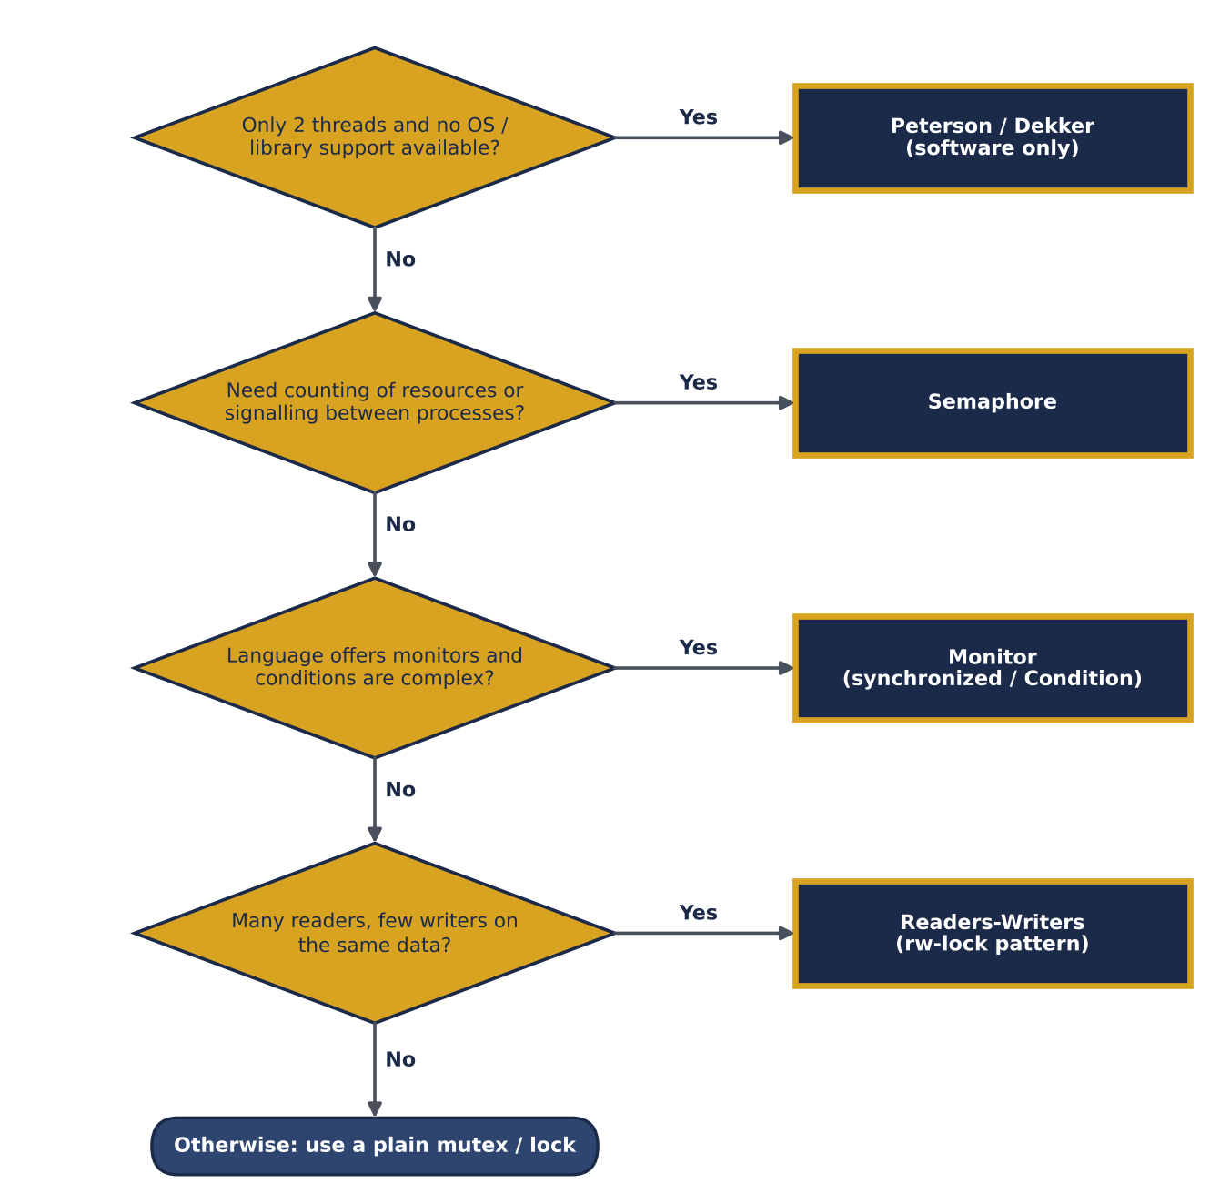
Figure 15 — Decision flowchart for choosing a synchronization mechanism
Final message
In practice programmers use ready-made library locks (pthread_mutex, synchronized, ReentrantReadWriteLock) instead of writing Dekker or Peterson; yet knowing these five algorithms explains why those locks are correct and what the common failures (deadlock, starvation, priority inversion) are.

References
[1] E. W. Dijkstra, “Solution of a Problem in Concurrent Programming Control,” Communications of the ACM, 8(9), p. 569, 1965.
[2] E. W. Dijkstra, “Cooperating Sequential Processes,” Technical Report EWD-123, Technische Hogeschool Eindhoven, 1965.
[3] G. L. Peterson, “Myths About the Mutual Exclusion Problem,” Information Processing Letters, 12(3), pp. 115–116, 1981.
[4] C. A. R. Hoare, “Monitors: An Operating System Structuring Concept,” Communications of the ACM, 17(10), pp. 549–557, 1974.
[5] P. J. Courtois, F. Heymans, D. L. Parnas, “Concurrent Control with ‘Readers’ and ‘Writers’,” Communications of the ACM, 14(10), pp. 667–668, 1971.
[6] B. W. Lampson, D. D. Redell, “Experience with Processes and Monitors in Mesa,” Communications of the ACM, 23(2), pp. 105–117, 1980.
[7] A. Silberschatz, P. B. Galvin, G. Gagne, Operating System Concepts, 10th ed., Wiley, 2018.
[8] A. S. Tanenbaum, H. Bos, Modern Operating Systems, 4th ed., Pearson, 2014.
[9] M. Herlihy, N. Shavit, The Art of Multiprocessor Programming, 2nd ed., Morgan Kaufmann, 2020.
[10] A. B. Downey, The Little Book of Semaphores, Green Tea Press, 2016.

